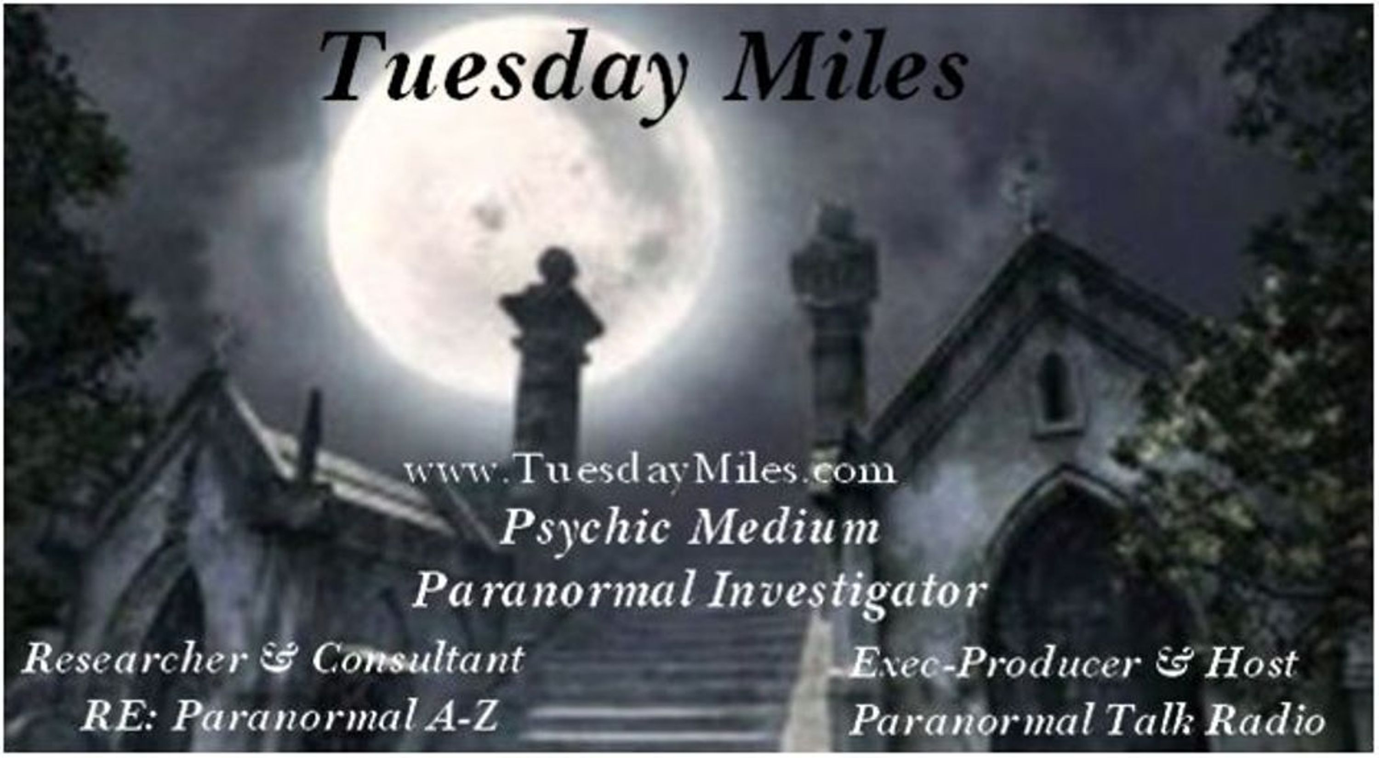
For most Psychic Mediums they will say they are a natural born psychic, at the age of two they noticed they had special gifts, my gifts had a different story. After the death of one of my parents 14 years ago, I had noticed something different about myself. The energy that surrounded me was clear, the sky’s were bluer, the grass greener, I was beginning to feel others emotional energy. At first my eyesight started to get burry, I felt strange, yet I did not understand why. One evening sitting at the kitchen table I felt a hand touch my shoulder, knowing there could not be any body behind me, I still turned around to look, and nothing was there. Cold air swirled around me; I had this eerie feeling as if something was watching me.
It wasn’t long after that night that I began to feel spirits around me, at bedtime the bed would shake softly, I would hear a whisper of my name ,thinking I was nuts. I found myself sitting at the window that overlooks my back yard watching the plants part as if someone was walking through them. I will never forget the night I climbed into bed, I felt something crawling around my ankles, the bed covers pull right off of me, I was dragged out of bed onto the floor. I never saw what it was that did this, although I did not wait around to look, I ran grabbed the phone and out the front door I went.
My Psychic gifts all of them sight, touch, sound, knowing, communicating all open up at once. My normal life left and now I had to learn life all over again. As of today I do not use all the gifts I was given some came and gone, others enhanced, I learned control, the do’s & don’t about being a Psychic Medium, it’s not always a pretty job, although when helping others here & on the other side the rewards are endless. Being a Medium takes dedication, responsibilities, trust, love, and discernment. Today I enjoy all avenues of being a Psychic Medium, as a consultant, a communicator to the dead, a soul rescuer, paranormal investigator, psychic researcher, I have expanded my knowledge to every corner of the other side, I help with many cases of haunting, personal, or residential. I have experience just about every type of spirit out there I call them the 101 variety. What I admire most about myself is, I am a proof person, and will go to endless means to document the proof we all seek in this.
I have clients all over the world who contact me for advice, messages from heaven, seek help, with an undesirable ghost; I have taught medium ship on paltalk.com, and in my private home. I am a consultant to many well known paranormal investigation researchers. In which I help with finding the problem first before any solution can be designed to move the entity up and out of the person, place or thing in which it is haunting. I teach paranormal investigating, to either new teams, or teams who are in the need of a new way to host a successful investigation. I do not put up with any bullshit a ghost wants to pull, and have no fear of anything but grasshoppers, and little white worms. Currently I have one book finished, and another one in the works. I live in Long Beach California with my husband and two teenage kids, my ever so smart Siberian husky dog
. Appearances,
TV,
Beyond with James Van Praagh
Dead Famous Live UK with Chris Fleming
Radio,
Coast to Coast Am with Art Bell
Coast to Coast Am with George Noory
Ghostly talk radio, with Scott & Doug
Lou Gentile show with Lou Gentile
Voices of the People with November Hanson
Dawn of Shades with Gia Scott
Angels among us, with host Georgette.
Published writings,
Research of Magnetic Energy Vs Ghosts.. Where I worked with the local electric company, for 30 days documenting the EMF, in a very active haunted house. 2008
The death of a Psychic, The Peter James story, 2007 publish on Ghostvillage.com
Orbs have they become that boring, 2006 publish on Ghostvillage.com
Blue Moon productions, the Poems of Kacee Miles, 2006 lulu.com
The Lemon Tree, unexplained-magazine, 2009
Coming soon, Ghost stories with Brad Steiger. 2009
Mediumship, the beginning 2008-2009
Novels,
Out of the Dark, Into the Light - in the final editing stage with new age books. 2009
The Gatekeeper, both fictional & non fictional , about a spirit gatekeeper in my home,
who controls a portal it opened inside of a shower stall.
Michael Laparne, Earthbound, script for the TV show Whispers
Spooktacular Cooking, Simple recipes even a ghost can do. Cook book designed for school age
elementary kids can sell to raise money for their school libraries.
www.myspace.com/portaltalkradio
www.portaltalkradio.com
www.TuesdayMiles.com

www.myspace.com/portaltalkradio
www.portaltalkradio.com
www.TuesdayMiles.com

